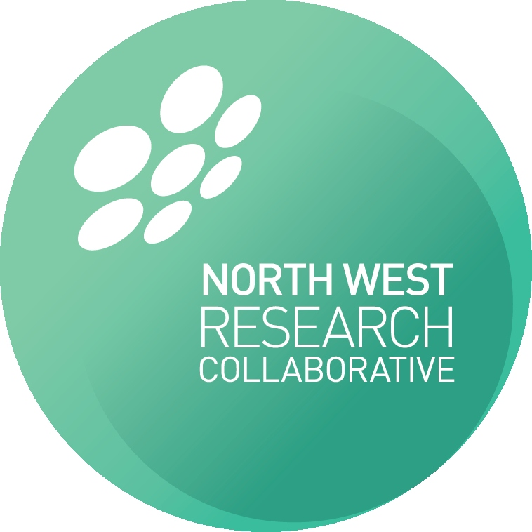

NWRC regional meeting
12/3/2014

Meeting minutes

North West Research Collaborative Meeting 3rd December 2014

Nightingale Centre, 18:30
Attendees: Nick Heywood (Interim Chair), James Nicholson (Associate Chair), Mike Gill (Secretary), Pete Coe (Associate Secretary), Hema Sekhar, Waqass Farid, Ben Starmer, Corinna Slawinski, Hamish Clouston, Arooba Shah, Stella Smith, Rebecca Harrison, John Quayle, Martyn Stott, Jane Hughes, Ruth Chelva, Petros Yiannoullou, Sarah Duff, Cliona Kirwan.
Apologies: Paul Barrow, Pete Charleston, Paul Shuttleworth, Jen Smith, Ben Hornung, Michael Ager, Lyndsay Pearce, Claire Goatman, Julia Poulter.

Agenda:

- Introduction and Welcome
- Policies and Procedures
- Current Projects
- New Project Ideas
- Medical Student Collaboration
- Yearly agenda and programme
- Any Other Business
The meeting was chaired by the new interim Chair, Nick Heywood.

Introduction and Welcome
NH welcomed all new attendees and gave an overview of the collaborative and its aims.

Policies
The authorship and project development policies that were distributed to the collaborative prior to the meeting were reviewed. There were no objections or queries, therefore accepted as policy. The policies are available to download from the NWRC website (www.nwresearch.org).

Current Projects

Coding Project
The coding project (NH lead) is virtually completed. The results were presented at this years ASGBI conference, with a manuscript undergoing its final reviews. It will aim to be submitted within the next few weeks. An add on part of this study reviewing teaching of clinical coding at an undergraduate level is underway.

SPLAT
SPLAT trial (PY lead) has had some delays in distributing the radiology questionnaire. However, this is now being sent out nationally. The surgical survey has been sent out, with responses now coming in. Further data has recently been received from TARN, which is currently being analysed.

Breast Subgroup
The Breast subgroup is currently underway with a retrospective audit reviewing implant loss rates, with 1yr data now mostly obtained. The prospective audit on the same topic is currently underway with approximately 40-50 cases recruited.

New Projects

Consent
The consent audit (CS lead) is planned as this years core trainee project. An overview of the project was presented along with a timeline for the project. The protocol aims to be fully developed by the next collaborative meeting in February, with data collection in April and May, and analysis complete by July. Approximately 700-800 patients will be needed to adequately power the project to identify complications from hernia repair.
Action: Protocol to be developed and presented at next collaborative meeting.

Extended VTE Prophylaxis
Extended VTE prophylaxis (AR lead) was discussed. NICE guidelines advise 28 days prophylaxis, although this is not a compulsory recommendation. There was debate regarding whether this should be a retrospective or prospective audit, comparing trusts that do use extended VTE therapy vs. those that don’t. Further debate was held as to whether a clinical trial should take place, comparing 0 vs. 28 day vs. 6 month therapy. Outcomes would be clinically significant 30/90 day VTE events, as well as mortality.
Action: Protocol to be developed and presented at next collaborative meeting.

Medical Student Collaboration
Josh Burke kindly attended and presented to collaborative. He is currently developing a database of all clinical and academic researchers within the North West, to allow medical students to be part of research projects during the holiday months.
JB also gave an overview of the planned Manchester Medical Journal. This is planned to be an open access journal, aiming to publish initially undergraduate work (e.g. from study modules, etc.). It has the backing and funding from Manchester Medical School with the head taking the role as Editor-in-Chief. There are 3 student editors currently. A tiered peer review system is being piloted with submissions first being reviewed for suitability by Level 1 reviewers (students with an academic interest), before being critiqued and passed to Level 2 reviewers (registrars within the field), before being passed to Level 3 reviewers (consultants / senior lecturers). As present there are 20 Level 3 reviewers who have expressed interest in being part of the journal.

Year Agenda
JN presented an overview of the years meetings for 2015. There are 5 meetings planned in 2015, with the first being in February. This will be a surgical sandpit where protocols for new projects will be presented. The November meeting will act as an overview for the year, and presentation of results from all collaborative projects.

Any Other Business

There was no other business. The meeting was brought to a close at 2015.

