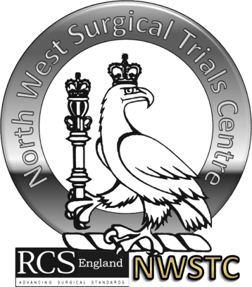
NORTH WEST SURGICAL TRIAL CENTRE

DEVELOPING CLINICAL TRIALS,
1stMay 2015, 12pm – 5pm

Application Form:
Name
Position
Current Employer
Speciality
Deanery Name
Special Dietary Requirement
If you have an idea that you wish to present at the showcase with member of clinical studies groups, please let us now the following:
• Title
• Idea
• What area of development you would particularly like assistance with?
The NWSTC is trying to develop a range of online course. Is there any specific areas/topics you would like to see developed?

Return to Gemma Nanson at g.simpson@liv.ac.uk or at fax to 0151 794 8930

