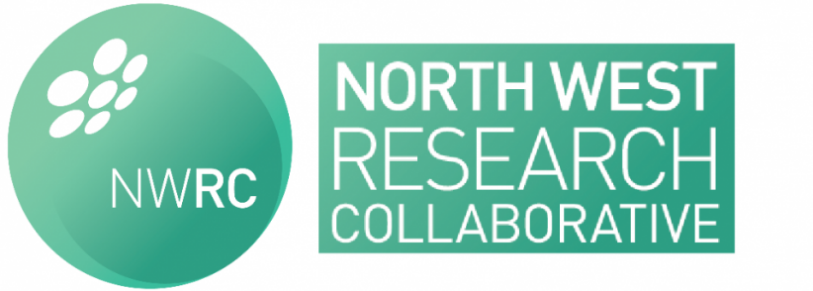

Agenda for NWRC Meeting 22nd April 2015
Nightingale centre - UHSM

- ACPGBI & BDRF Delphi Exercise
  - Feedback from latest patient consultation exercise
  - Delphi Games
- Other Collaboratives
- Breast Collaborative
- Projects
  - Coding
  - Gastroscopy and H.pylori project
  - Extended DVT prophylaxis project
  - New project ideas
- End of Year meeting
- Any Other Business

