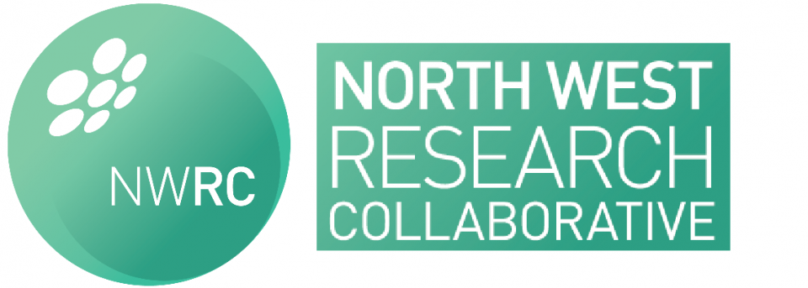

North West Research Collaborative Meeting, MAY 2016

Nightingale Centre, Wythenshawe Hospital, 4th May 2016: 18:30
Chair: Nick Heywood (Chair)
Minutes: Martyn Stott (Assistant Secretary)

IN ATTENDANCE
N Heywood (Chair), P Coe (Vice Chair), M Stott (Assistant Secretary), L Walker (FY1), A Hague (FY1), R Hasan (FY1), C Slawinski (ST3 – Consent Lead), M Gill (ST6), S Duff (Consultant Colorectal Surgeon).

APOLOGIES
H Sekhar (Secretary), J. Nicholson, K Newton, A Rees, H Clouson (SUNRRISE Lead)

Agenda:
- Tips & tricks of setting up a regional audit
- Inguinal Hernia Consent Audit
- Extended DVT prophylaxis
- New Project Ideas
- Other Project updates
  - Coding
  - Perianal Crohn’s fistula (Surgical and Medical)
  - SUNRRISE
- Update on committee
- AOB

TIps & tricks of setting up a regional audit
NH gave a short presentation outlining the achievements of the collaborative over the 3 years since its inception. He also gave tips on how to set up a regional audit and the difficulties that may be encountered along the way. New members were encouraged to be involved in projects.

Inguinal Hernia Consent Audit
CS gave an outline of the results and progress of the Consent Audit. 1 poster presentation has been presented at ASiT in Liverpool and 2 further poster presentations have been accepted to the European Hernia Society Conference, Rotterdam. The results of the audit were presented in terms of the primary and secondary outcomes (consent and educational opportunities). SD suggested the secondary outcomes should be presented to the trainer body of the region to outline how training could be improved. Feedback to participating trusts will be disseminated soon by the steering group.

Extended DVT prophylaxis
NH gave an update on this audit. It will look at extended DVT prophylaxis in colorectal resections and the opportunity to open it up to national DVT prophylaxis practice in other specialities. A trial had been conducted of the methodology at UHSM. It is anticipated that 15 collaborators will be needed. NH suggested if any members still wished to be a collaborator to contact the Committee.

New Project Ideas
RH presented an idea about an audit that FY1s at Tameside are conducting relating to Consent and Capacity. MG suggested that it needed to be established if there was national guidance on this which could be attained from SNs in Learning Difficulties. RH should present a formal proposal if this wants to be taken further.
NH suggested a pedometer study idea comparing different grades of doctor and weekend/weekday distances covered as a project for the Christmas BMJ. This was welcomed by those present.

Other Project updates

Coding
Accepted for publication which was congratulated by the attendees.

Perianal Crohn’s fistula (Surgical and Medical)
NH outlines this project that is joint between SYSURG (South Yorkshire) and NWRC through the Delphi ACPGBI process. The surgical aspect is collected and 2 manuscripts are in press for publication. The medical data collection is currently under way and anyone wanting to be a collaborator should contact the committee.

SUNRRISE
A steering group has been formed and a draft protocol written. There are formal talks ongoing with the NWSTC and Smith & Nephew. Further updates once the protocol is written will be disseminated.

Update on committee
There had been a change in committee positions since the latest elections. We thank James Nicholson as Outgoing Vice Chair and Mike Gill as Outgoing Secretary for their hard work. We welcome Hema Sekhar and Martyn Stott to the committee as Secretary and Vice Secretary. Pete Coe is now Vice Chair.

Any other business
NH discussed the fact that meeting attendances were falling and ideas to suggest how we could reinvent the collaborative/improve attendance. It was noted that although members did not always attend they took part in projects, as highlighted with CST input to the Consent Audit. NH suggested if a survey of members would be beneficial but it was deemed this would be poorly filled in. MS suggested moving some dates to the days of ST3+ teaching in Chorley as this would be more central and likely to improve ST3+ attendance, and still have some at UHSM following CST teaching. There will be a committee meeting to further discuss these ideas.
The meeting was adjourned.

