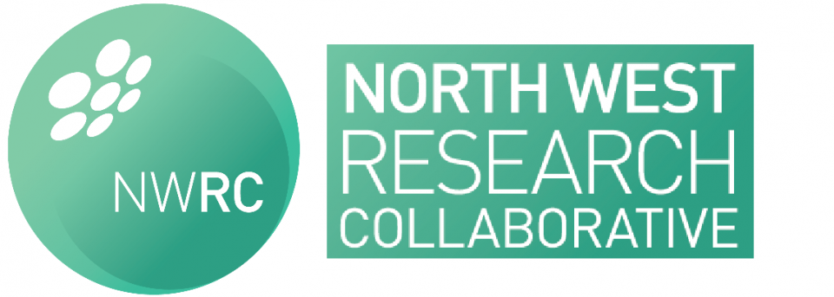

Meeting Agenda – 18:30-19:30, Wednesday 8th March 2017

UpsTairs at the Nightingale Centre, UHSM

18:30 – 18:35 Welcome

1835-18:45 National Collaborative MEeting
The meeting was extremely successful and we had 3 oral presentations. Feedback was excellent and the national group was very complimentary about the progress we have made as a collaborative group. We are looking to form a committee which will be responsible for organising the 2018 NRCM. Ideas of committee roles required

18:45 – 18:50 – eras+
Ms Gemma Faulkner, Consultant Surgeon at Bolton, is coming to discuss the ERAS+ project which is being rolled out across trusts in the northwest. We will be looking for a representative from the NWRC to help with this.

18:50-19:00 – PPAC
Katy Newton will be giving an update on the progress with PPAC and the upcoming funding grant we are due to receive from the RFPB. We are close to the start of this study and a full launch meeting will take place in due course.

19:00 -19:15 - Ongoing Study updates
VTE prophylaxis – data collection is ongoing with the majority of contributors returned the CRF. For those who have yet to return their forms, please do so to enable data analysis to be completed
ELF (emergency laparotomy& frailty) – This study is making leaps and bounds and we have recruited 50 sites. Due for rolling out on 20th March
SUNRRISE – use of negative pressure wound therapy in emergency laparotomy. Now in the stages of applying for funding for this study. Industry has agreed to provide the required dressings for the study.
Laparoscopy in Emergency Surgery – steering committee is formed and we are underway in developing a protocol
NASBO – this is underway in the region and is due to finish mid-March. Will all sites ensure that patients are identified and uploaded onto REDCAP.

19:15 – 19:25 - Committee roles and elections
We will discuss the outcome of the latest committee roles elections and the ongoing role of the committee

19:25 New study proposals
If there is anyone who would like to discuss upcoming study ideas, please bring them to the meeting for discussion

19:30 Any other business and close
REDCAP – we will have access to this online database manager for our studies. We are expected to apply for funding to help the NWSTC fund ongoing support for this system and servers

